[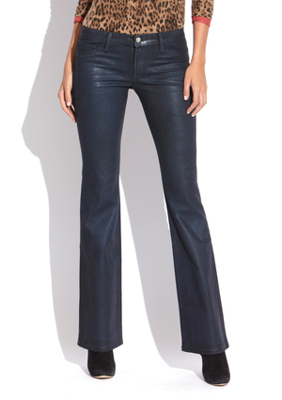](http://2.icdn.ideeli.net/attachments/142118530/430116259434-1_grid_image_zoom_largegrid_image_zoom_large900x1275.jpg)[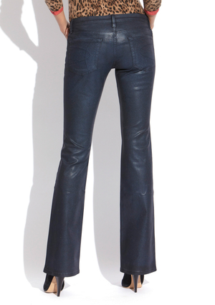](http://3.icdn.ideeli.net/attachments/142118722/430116259434-2_grid_image_zoom_largegrid_image_zoom_large900x1275.jpg)