 | 180 (IN-21-015) | Peach | 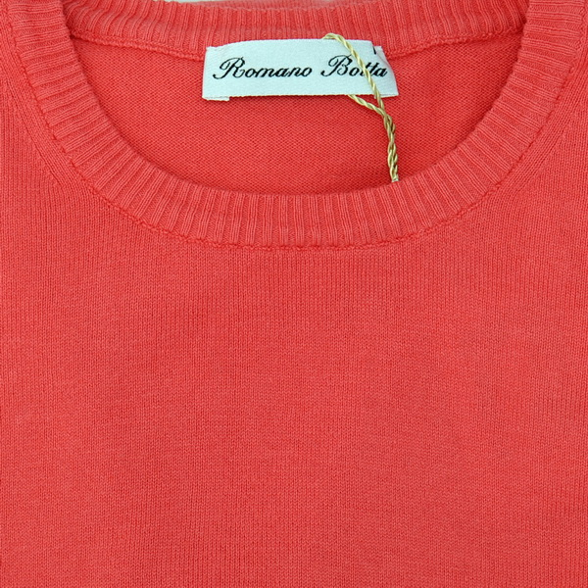 | 28.32
 | 180 (IN-21-016) | Light Blue | 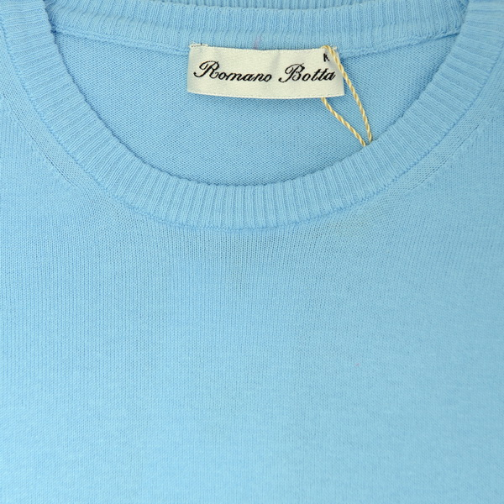 | 28.32
 | 180 (IN-21-014) | Light Lilac | 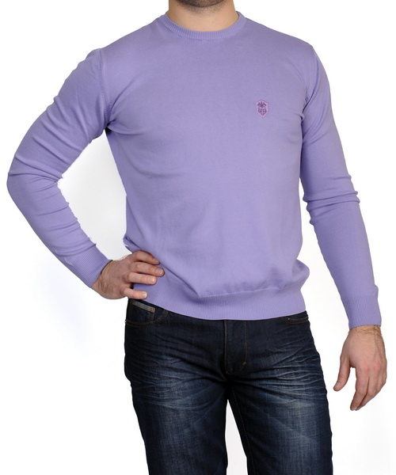 | 28.32
 | 180 (IN-21-015) | Red | 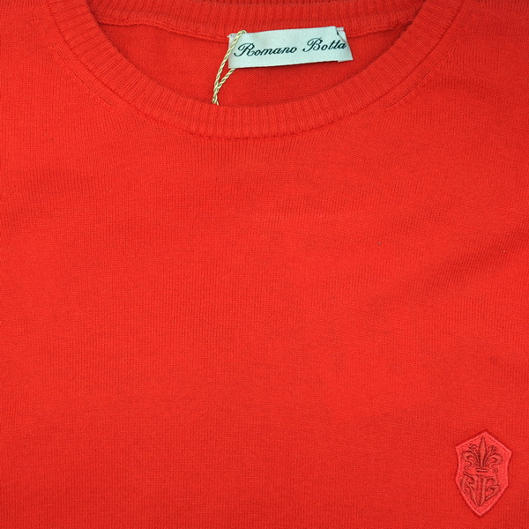 | 28.32
 | 180 (IN-21-015) | White | 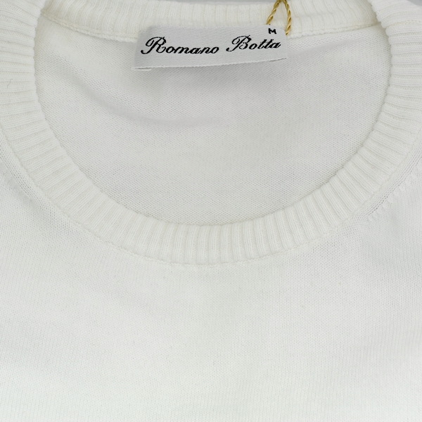 | 28.32
 | 170 (IN-21-011) | Orange | 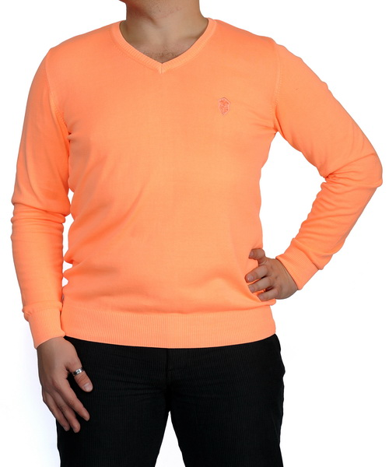 | 28.32
 | 170 (IN-21-012) | Black | 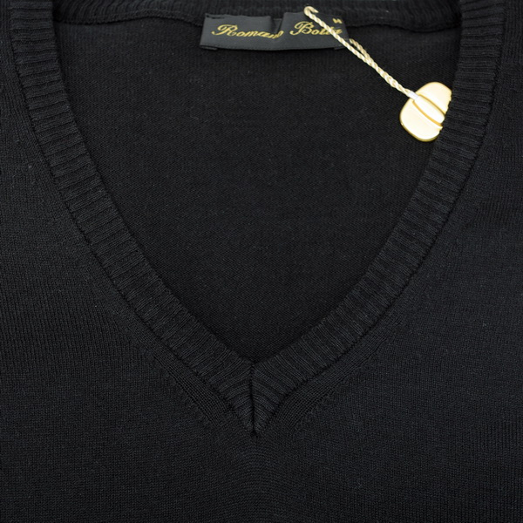 | 28.32
 | 1209 OR-21-007 | Green | 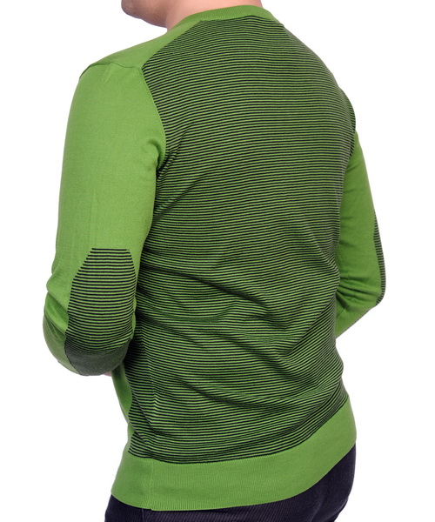 | 57.82
 | 1209 OR-21-006 | Dark blue | 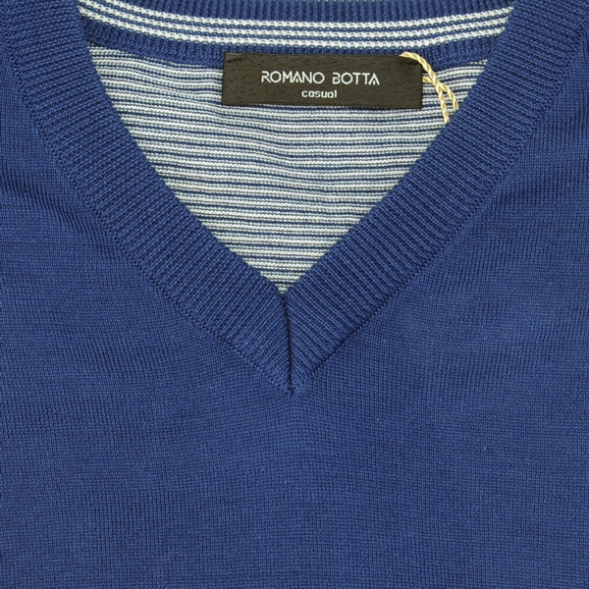 | 57.82
 | 1209 OR-21-006 | Light Blue | 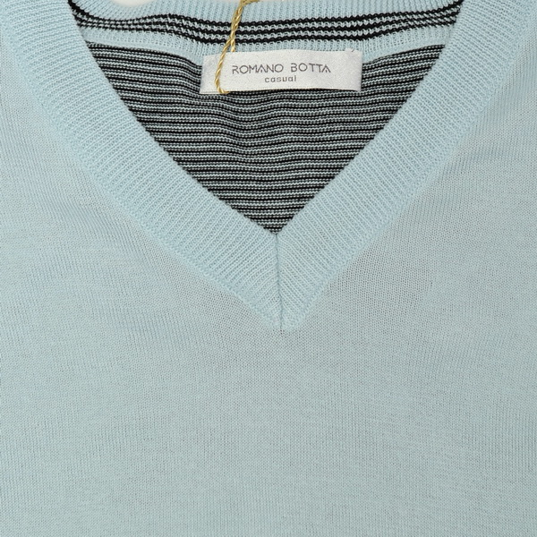 | 57.82
 | 1209 OR-21-006 | Blue | 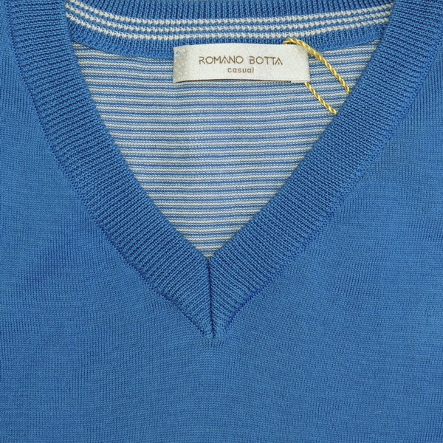 | 57.82
 | 2223 OR-22-001 | Vermilion | 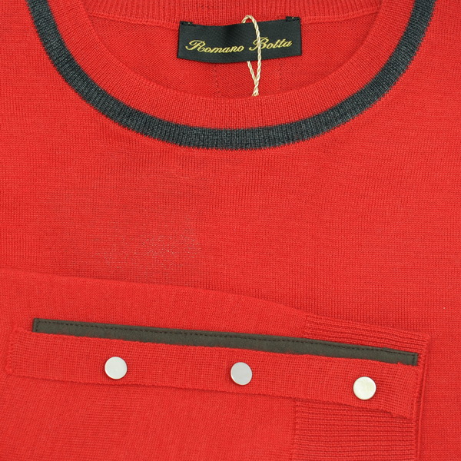 | 57.82
 | 2223 OR-22-001 | Yellow | 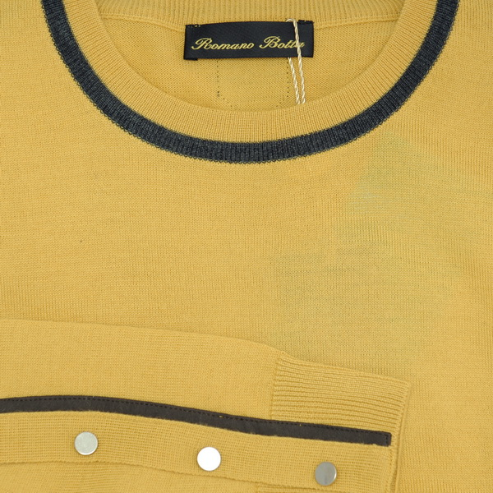 | 57.82
 | 2223 OR-22-001 | Saxe |  | 57.82

